**Kadane’s Algortuhms & Subarray, Subsequence & Substring Concepts –**

#include <bits/stdc++.h>

// #include <iostream>

// #include<algorithm>

// #include<climits>

// #include<string>

// #include<cctype>

// #include<vector>

// #include<set>

using namespace std;

// int main()

// {

**// Qun - Print Maximum sum of SubArray. Coondition - Sub-array must not be empty –**

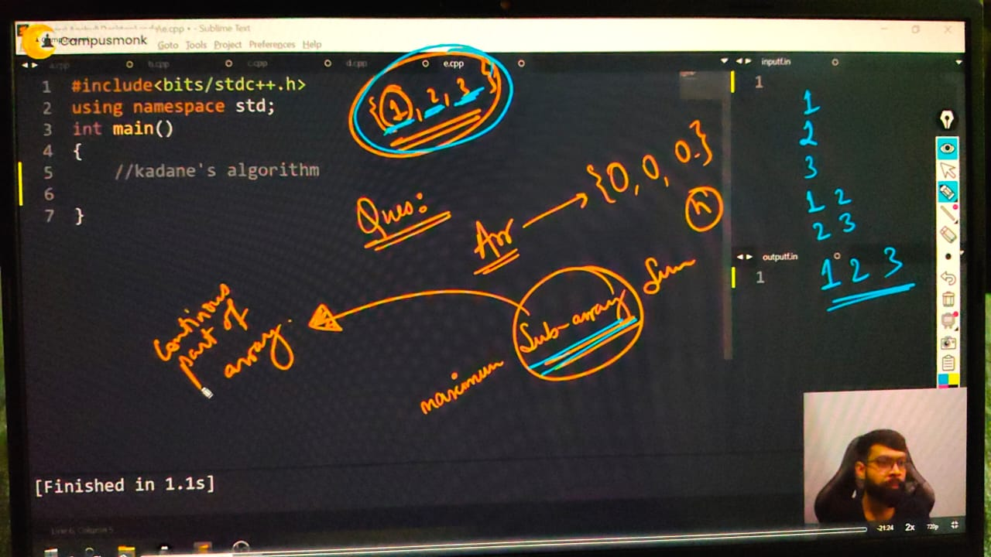

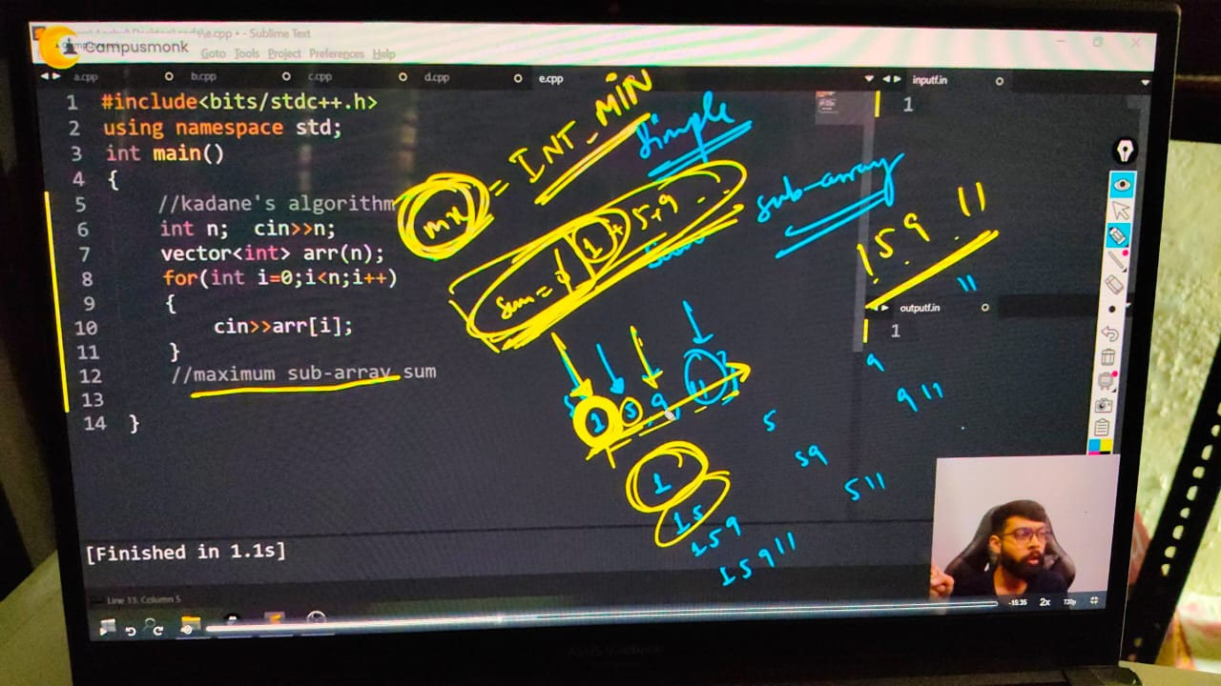

// int n;

// cout << "size of array - " << endl;

// cin >> n;

// vector<int> arr(n);

// cout << "Give elements of array  - " << endl;

// for (int i = 0; i < n; i++)

// {

//     cin >> arr[i];

// }

// // Maximum subarray sum -

// int ans = INT_MIN;

// for (int i = 0; i < n; i++)

// {

//     int sum = 0;

//     for (int j = i; j < n; j++)

//     {

//         sum += arr[j];

//         ans = max(ans, sum);

//     }

// }

// cout<<ans<<endl;

/*

size of array -

5

Give elements of array  -

1 4 -7 11 5

16

T.C - here the time complexity is - O(n*n = n^2)

 */

// ____________ ____________

**// Kadane's ALgorithms –**

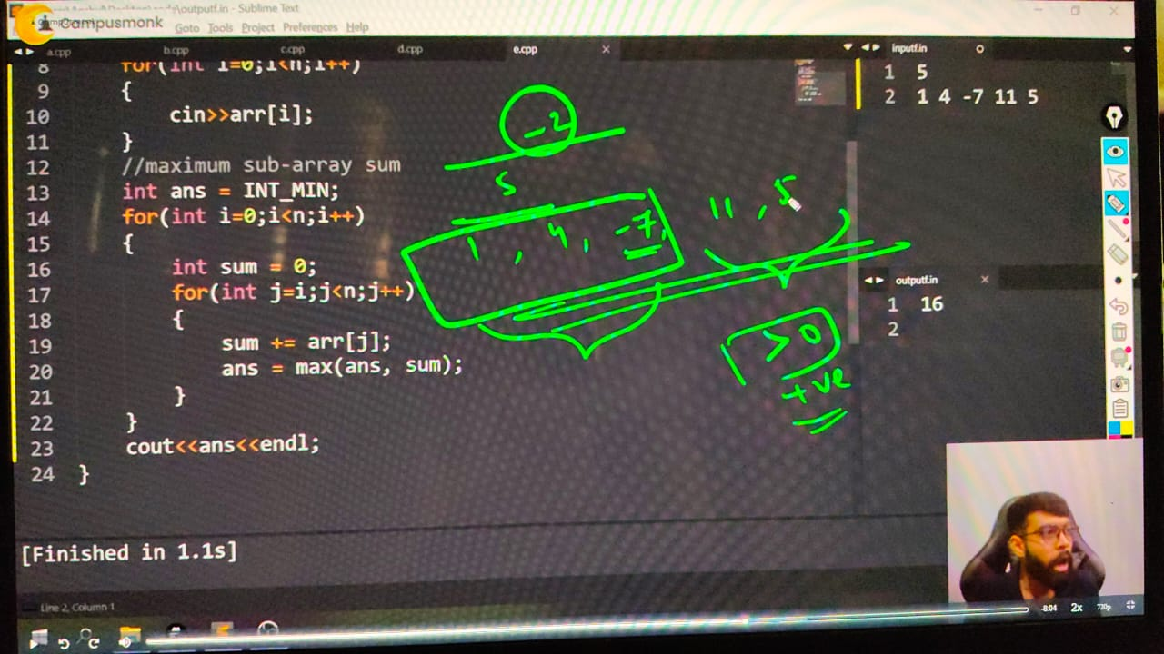

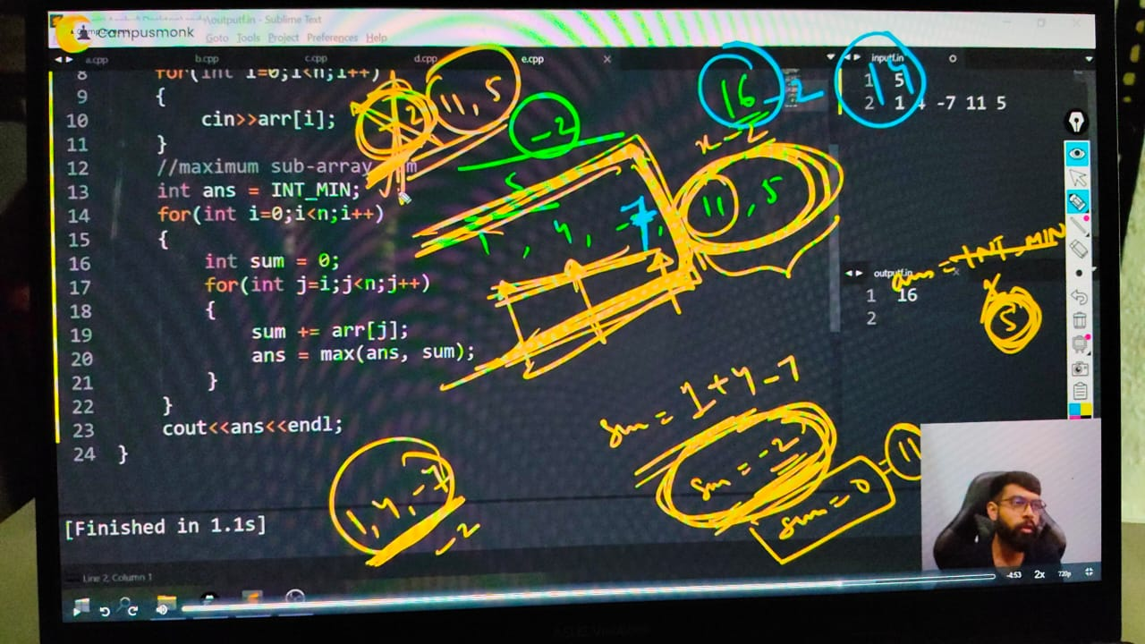

// So, for decreasing this much complexity using Kadane's ALgotihms - Acc. ot this aalgorithm don;t addd to those elements which is negative , leave the sum zero, and incldue only possitive numbers sum

// int n;

// cout << "vector size - ";

// cin >> n;

// vector<int> arr(n);

// cout << "What are the vector elements - " << endl;

// for (int i = 0; i < n; i++)

// {

//     cin >> arr[i];

// }

// // For max sum array using Kadane's algorthms -

// int ans = INT_MIN;

// int sum = 0;

// for (int i = 0; i < n; i++)

// {

//     sum += arr[i];

//     ans = max(ans, sum);

//     if (sum < 0)

//     {

//         sum = 0;

//     }

// }

// cout<<"hence the maximum sum can be print as - "<<ans<<endl;

/*

vector size - 5

What are the vector elements -

1 4 -7 11 5

16

vector size - 5

What are the vector elements -

1 4 -3 11 5

hence the maximum sum can be print as - 18

T.C - O(n) - no any unnecessary loops

S.C - O(1) - constant because of only 2 variable declared

 */

// }

// ____________ ____________ ____________ ____________ ____________

**//  Qun - Print all subsequences of an Array or String**

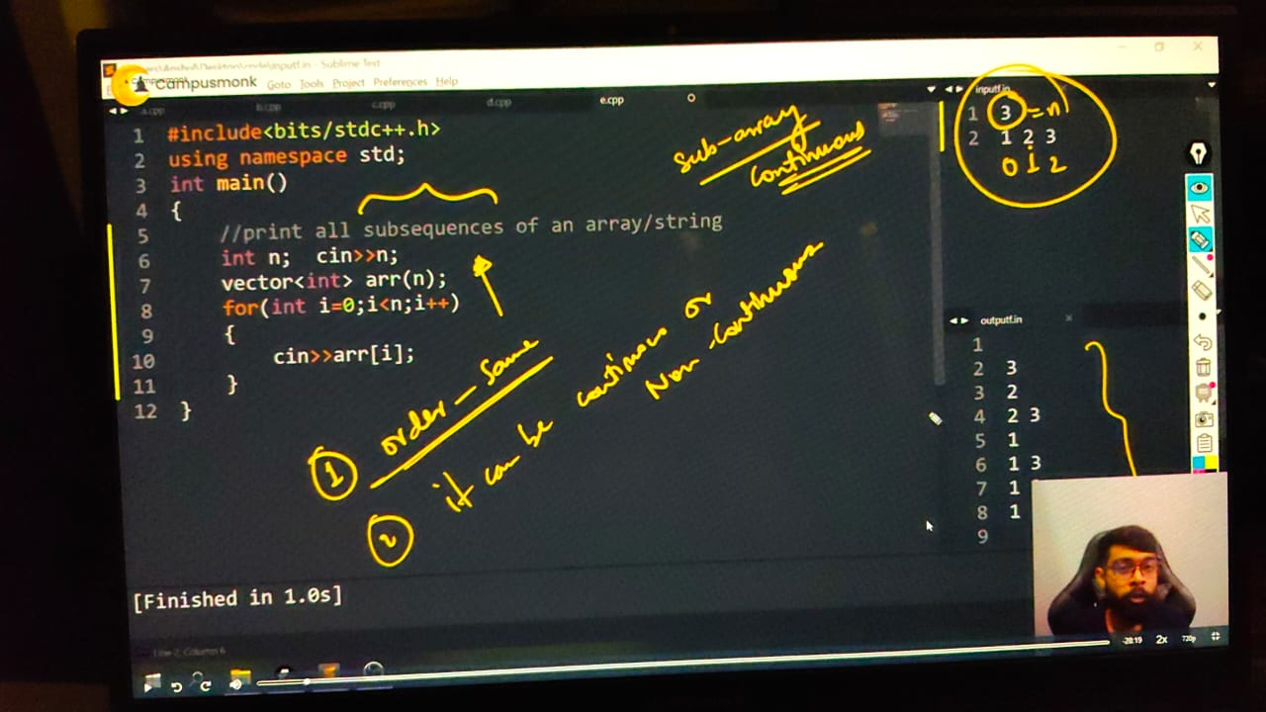

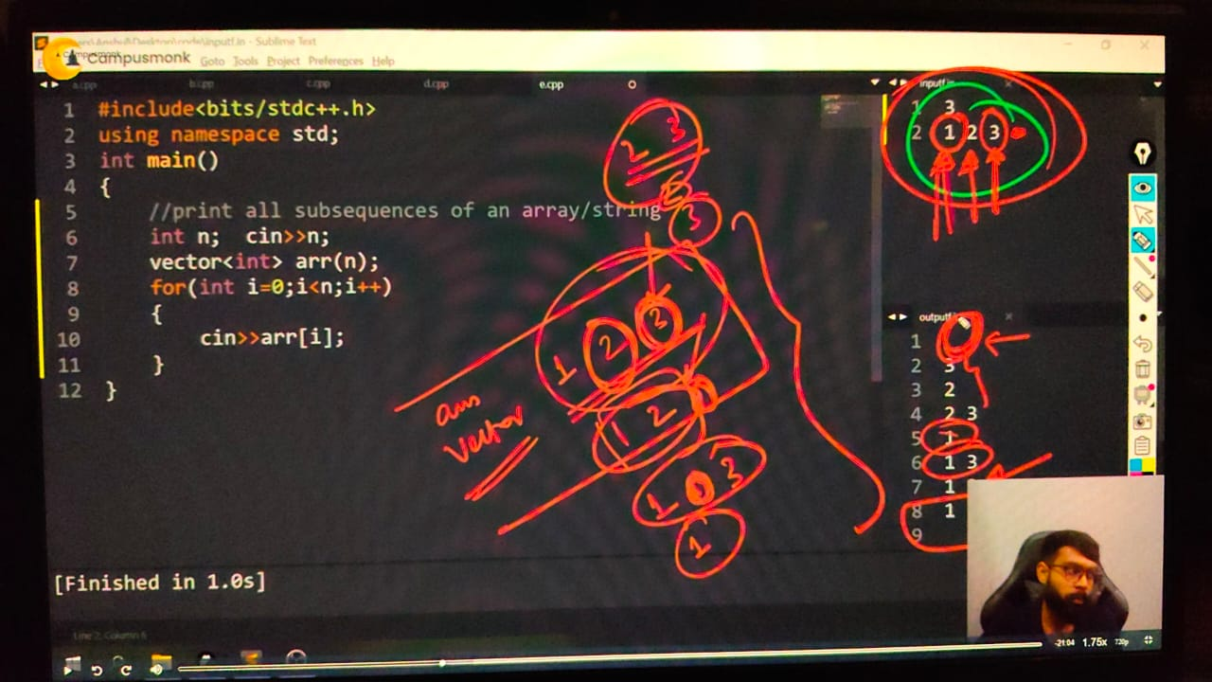

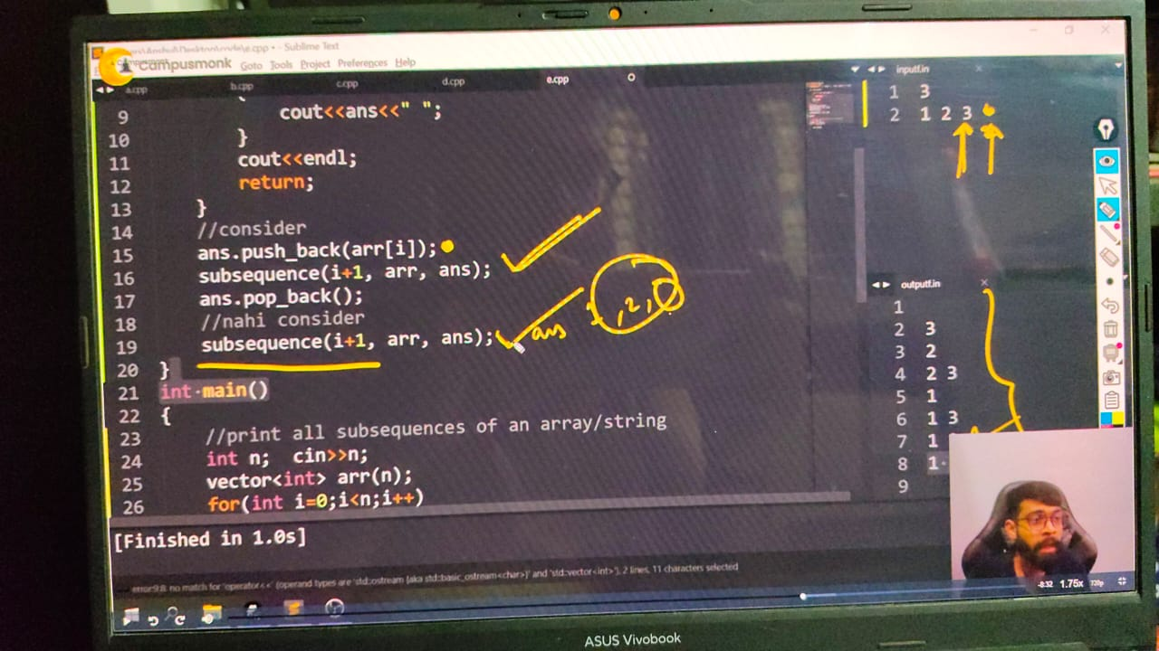

/*  Subsequence  - ALl the array eleemnts possible with the same order as well as it can be contigeous

Ex - [1,2,3] - {Empty}, {1},{1 2},{1 3},{1 2 3},{2},{ 2 3},{3}

backtracking - In one case we select something but in the another case we re not selectin g its a Bactracking approach

*/

// void subsequence(int i, vector<int> &arru, vector<int> &ans)

// {

//     if (i >= arru.size())

//     {

//         for (int j = 0; j < ans.size(); j++)

//         {

//             cout << ans[j] << " ";

//         }

//         cout << endl;

//         return;

//     }

//     // element to be consider

//     ans.push_back(arru[i]);

//     subsequence(i + 1, arru, ans);

//     ans.pop_back();

//     // nahi consider krna he

//     subsequence(i + 1, arru, ans);

// }

// int main()

// {

//     int n;

//     cout << "What's your array seize" << endl;

//     cin >> n;

//     vector<int> arru(n);

//     cout << "Mention the elememnts of array you want dude " << endl;

//     for (int i = 0; i < n; i++)

//     {

//         cin >> arru[i];

//     }

//     vector<int> ans;

//     subsequence(0, arru, ans);

//     /*

//     AGr condition di h ki emepty hoga ki nahi to uske according code likhene. If menetion that Subsequence not be empty then different, if mention can be empty then difeferent

//     so, jb saare elemnets me condition aa rhi ho ki consider krna he ki nhi then rmeeber always use recursion

//     */

// /*

// What's your array seize

// 3

// Mention the elememnts of array you want dude

// 1 2 3

// 1 2 3

// 1 2

// 1 3

// 1

// 2 3

// 2

// 3

// */

// }

// ____________ ____________

// Qun - print all subsrtings of a givcen string -

void subsequence(int i, string &s, string &ans)

{

    if (i >= s.size())

    {

        cout << ans << endl;

        return;

    }

    // Include current character

    ans.push_back(s[i]);

    subsequence(i + 1, s, ans);

    // Exclude current character

    ans.pop_back();

    subsequence(i + 1, s, ans);

}

int main()

{

    string s;

    cout << "What is your statement - " << endl;

    getline(cin, s);  // Use getline to accept full statement

    string ans = "";

    subsequence(0, s, ans);

    return 0;

/*

What is your statement -

abc

abc

ab

ac

a

bc

b

c

*/

}